
Jira

Jira is a project management and issue-tracking tool used by teams to plan, track, assign, and manage work throughout the software development lifecycle.
It helps teams organize work into items such as Epics, Stories, Tasks, and Bugs, assign them to team members, track progress using workflows (To do, in progress, done) and ensure timely delivery.
Jira is widely used by Product, Development, QA, and DevOps teams to collaborate efficiently, maintain transparency, and improve project visibility.

Following are the steps to proceed using JIRA:
- Login and go to home page

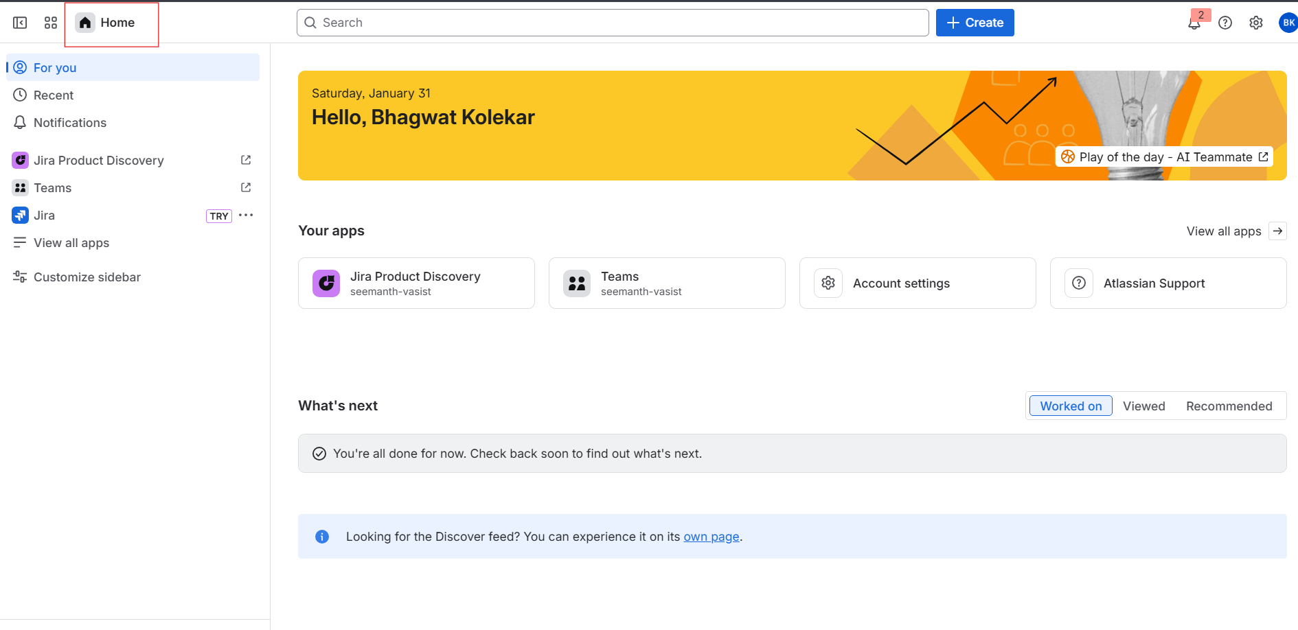

- To create new task click on “Create”

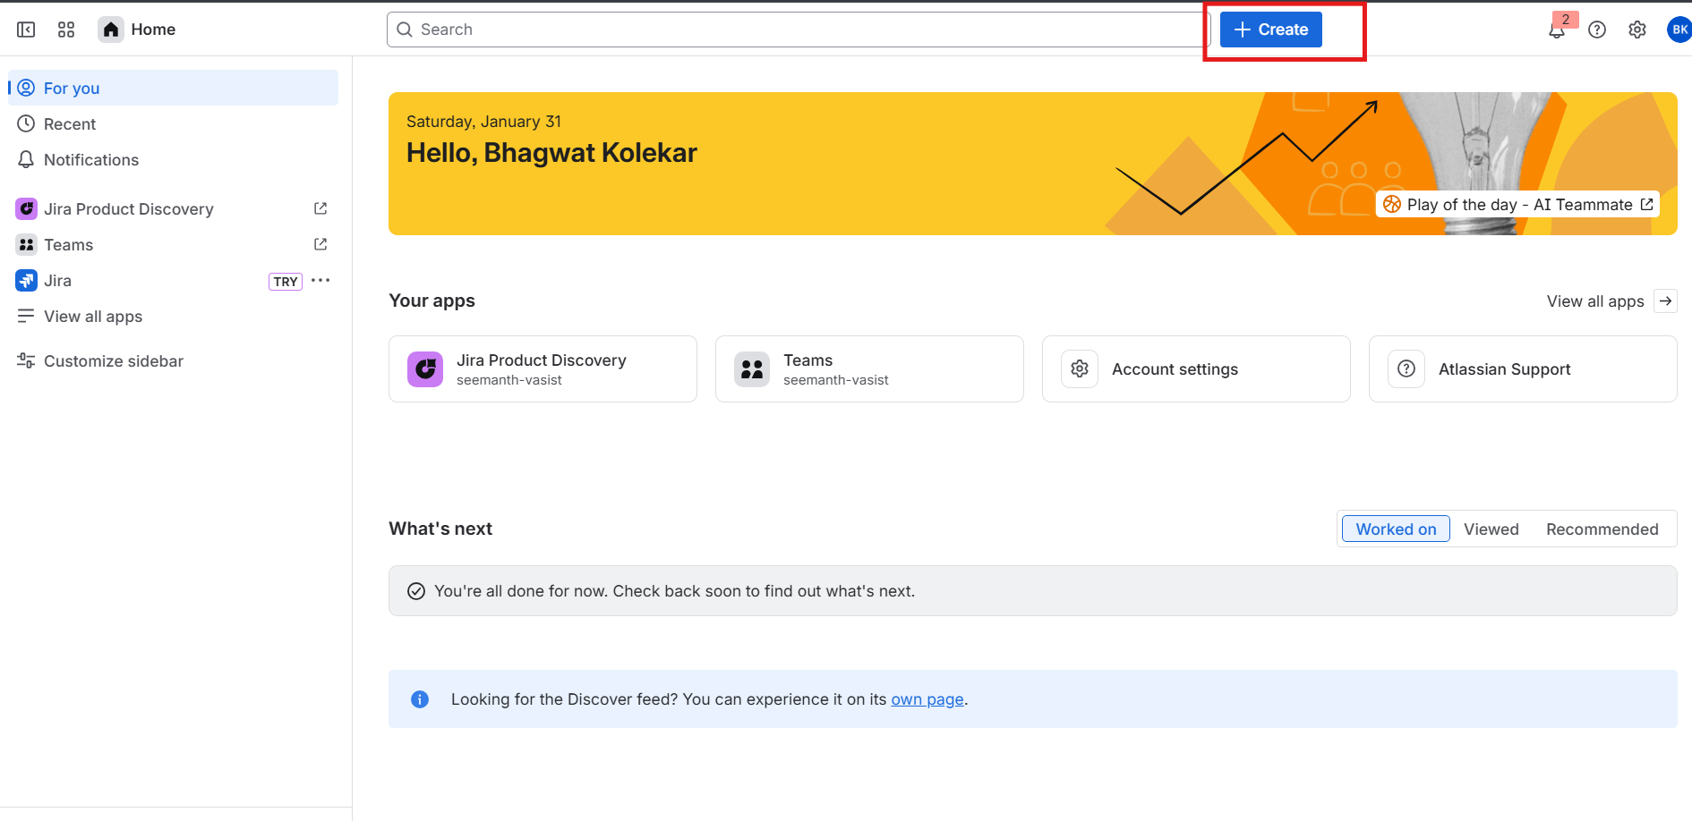

- Add Space and work type and also mention status of task

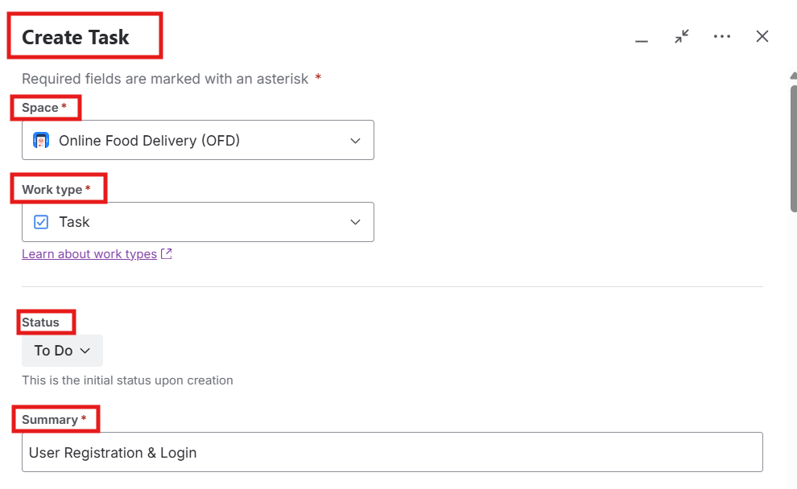

- Add Description of task, assign task to team member and task reporter, Priority

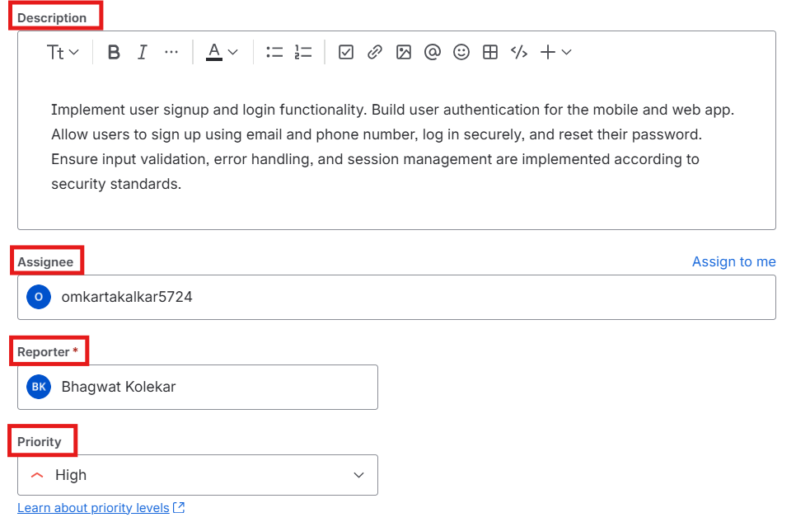

- Add start and end date for task and also add files for task if required

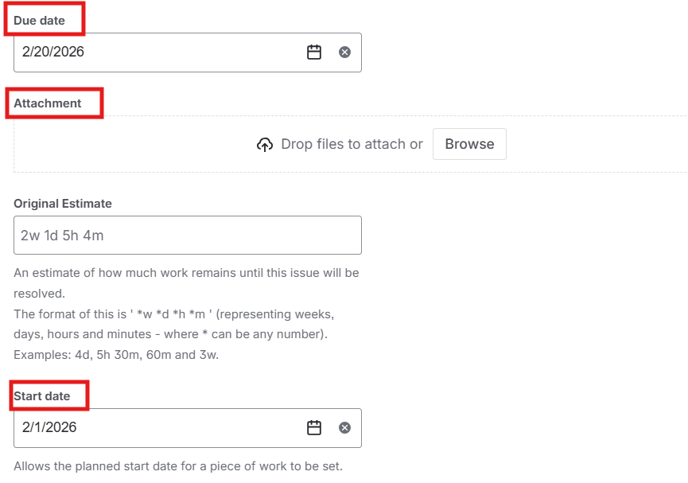

- Mention Team and Budget of task, then click on create

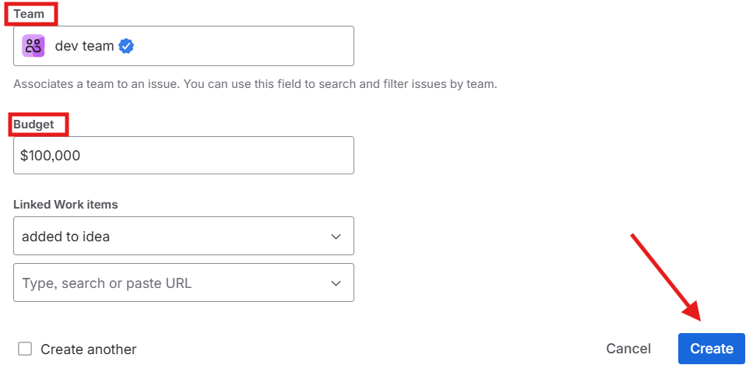

- Add comment and reply to comment

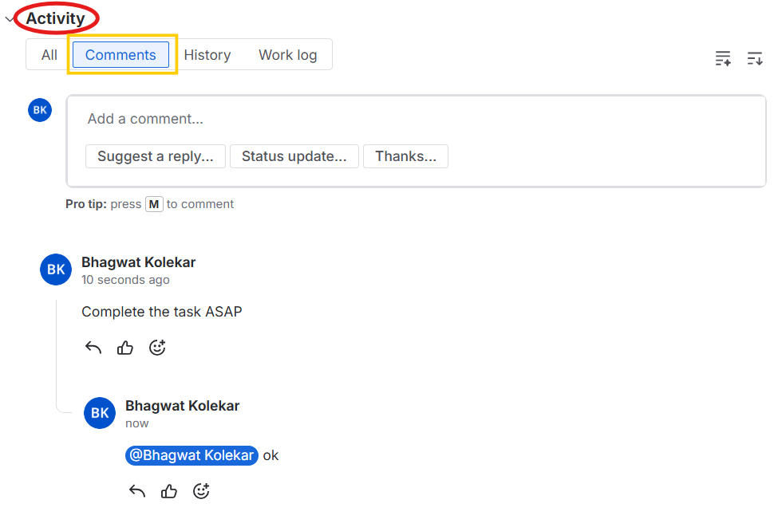

- Workstorm

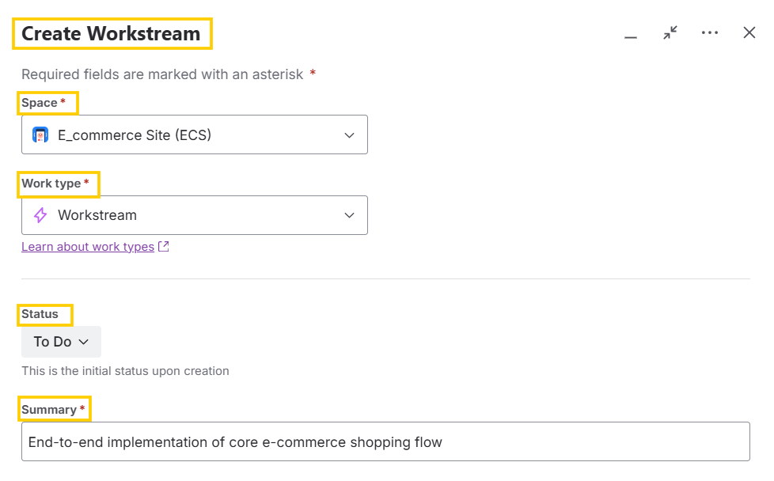
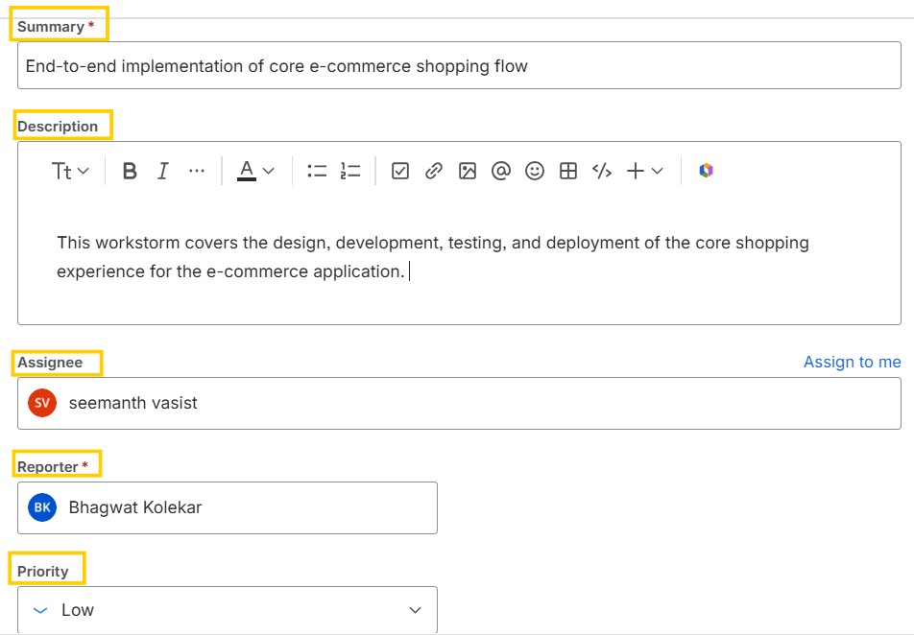

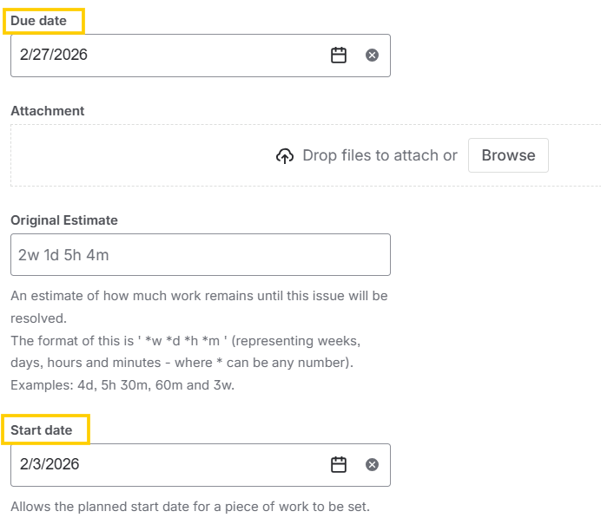

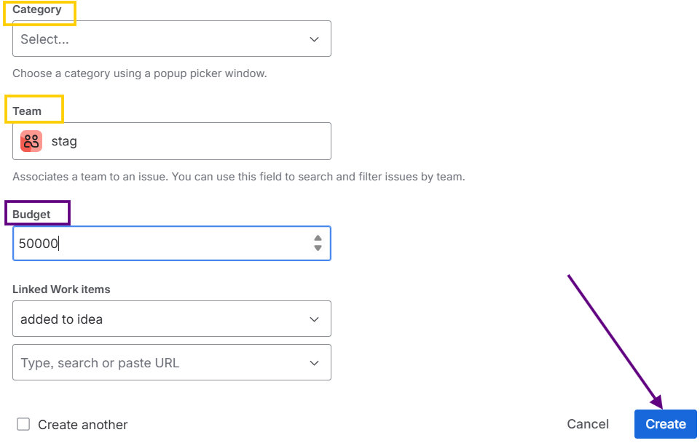

After creating the tickets, the results will be as shown:

